4th Grade Gifted News

It's great to be back into the swing of things. The students are adjusting well to the new routine and getting into the habit of transitioning from the regular classroom to the gifted classroom. I'd like to share with you what we have been working on for the past few weeks.

Reading:
We have begun reading and studying the novel, Charlotte Doyle. This is a fast -paced and suspense-filled novel where the main character, Charlotte Doyle, is faced with many challenges on her sea adventure in 1832. We started the unit by learning about virtuous traits and we are looking for evidence as we read to see how characters are displaying the different traits we learned about, such as autonomy, confidence in reason, or fair- mindedness. During our class discussions, we talk about the traits and evidence, and are learning to share our ideas together.

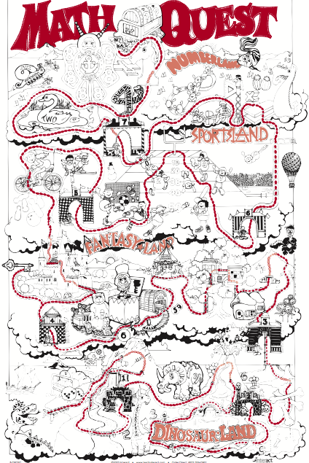
Math:
The 4th graders continue to solidify their algebraic skills through our Hands-On-Equations program! So far, we have reviewed the 7 lessons in Level 1 and have begun our study of Level 2! In this level, students will learn about the opposite of x, or “star,” and translate algebraic equations, such as
2(3x+1) = x + 22

Social-Emotional
The students are working on updating their Weebly sites to keep them current. They should actively work on these throughout the year to showcase their best work and highlight their personality and achievements.

As you can see, we are extremely busy in the time we have, but we are all enjoying every moment of it.

Thank you for signing the learning contracts. It's so important that the students know we are all working together with them, and if you have any questions, please feel free to contact me at anytime.

Attached is the permission slip for Camp Duncan, our District 70 Gifted field trip. The kids have a wonderful time each year getting to know everyone and participating in great team building activities. Please return the slip and payment by Friday, October 13 to the GTE classroom.

Kristin Morden
GTE Resource Teacher
kmorden@d70schools.org

