4th Grade October Gifted News

The gifted students have continued to work hard this month! Here is an update on what we are currently working on! It was great to see you at conferences and talk about the wonderful progress the students have made!

Reading:
One way to tell a true friend from a scoundrel is...
Reporting the grumblings of a ship’s crew to the captain can lead to...
Ignorance is no excuse means...
These are just a few of the reading response prompts that students think about during our novel study of The True Confessions of Charlotte Doyle. Students share written responses on our google classroom document and add details pertaining to the chapter after reading. Students are also taking anecdotal notes during reading while finding examples of virtuous traits in the book. For example, Charlotte showed “intellectual courage” when she told Captain Jaggery about the Round Robin, even after she was given a warning! Ask your child to log-in and show you their responses. We are anxiously waiting to find out what is in store for Charlotte!

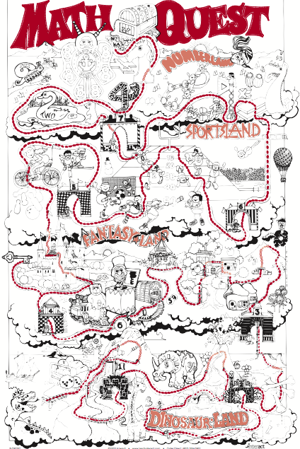
Math:
The 4th graders continue to solidify their algebraic skills through our Hands-On-Equations program! We have been working on our study of Level 2! In this level, students are learning about the opposite of x, or “star,” and translate algebraic equations, such as
2(3x+1) = x + 22
As they solve math problems, students earn “travel dots” on our Math Quest. Along the way, teams gain powers and face various obstacles they must overcome with the draw of Fate Cards. Let’s see how many students can make it all the way to the treasure chest! Ask your child to show you their work from Hands-On-Equations! It is exciting to see the students apply the algebra strategies they have learned to solve difficult problems!

Gifted Team Time
Each week, students in 3rd, 4th, and 5th grade gifted classes all come together for special Gifted Team Time activities. For the last several weeks, our focus has been on having a Growth Mindset. Through Khan Academy’s LearnStorm resources, students are learning about the brain and how to build a strong mindset. Even though these students are very bright, it is still important to grow your brain by having a Growth Mindset!

We had an AMAZING time socializing with our gifted friends at Camp Duncan! It was great to see how the students showed a Growth Mindset during our activities. They participated in the Rock Climbing Wall, Team Games in the forest, and Camp Duncan’s version of an Escape Room! If you would like to see some pictures from our day, please visit your child’s Weebly website.
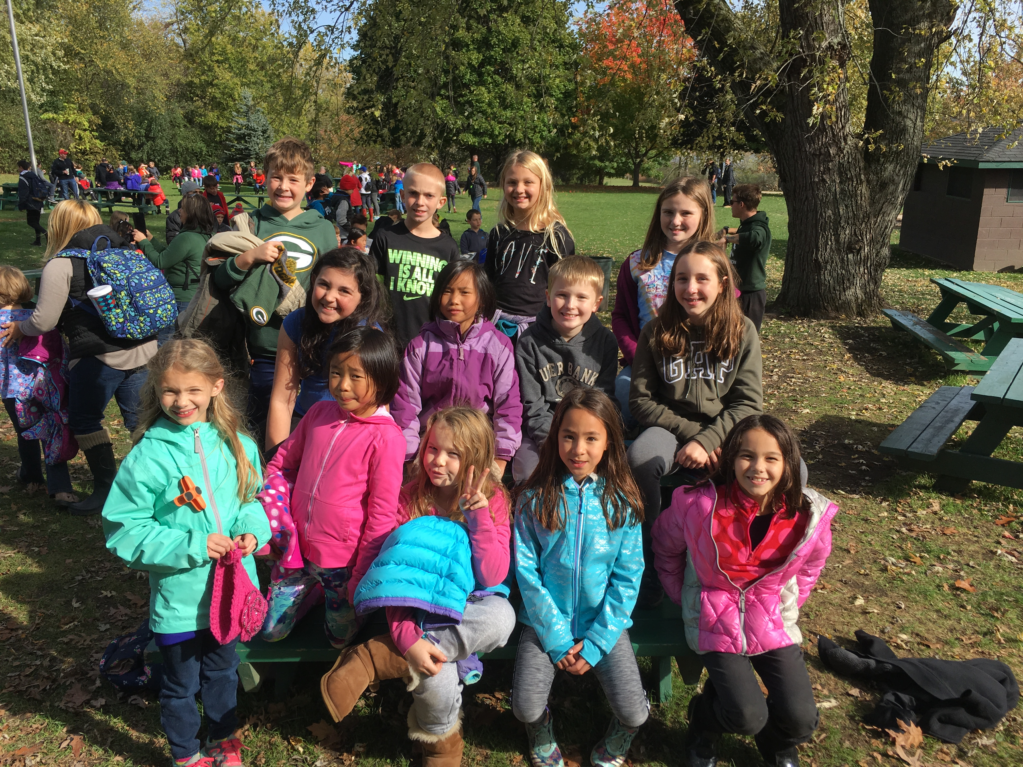

Mrs. Michelle Salm GTE Resource Teacher
msalm@d70schools.org

