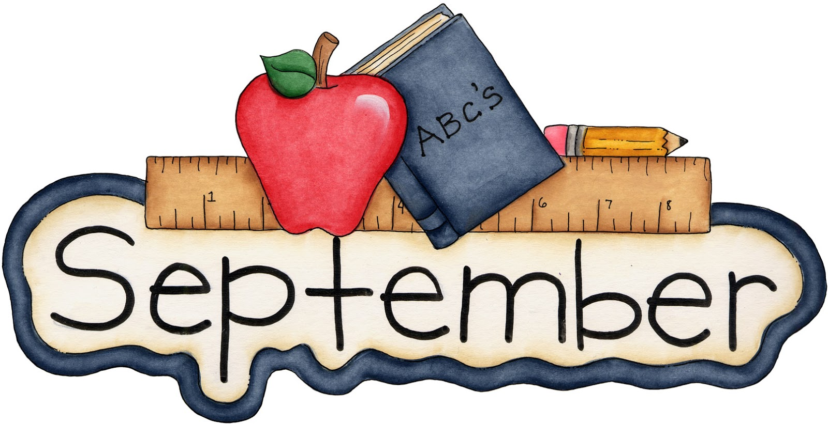
3rd Grade Gifted News

I'm happy to report our 2017-2018 school year is off to a wonderful start. The students are learning to transition smoothly from their regular classroom to the gifted classroom, manage schoolwork from both classes, and develop a sense of community in all areas of their day. These are skills that are going to be valuable to them throughout their academic career.

I'd like to share a little about what we are doing with our time in the gifted classroom with you.

Reading:
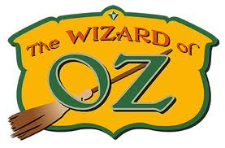
We have begun our first novel study, The Wizard of Oz. It’s a great fantasy with superior figurative language throughout. The students are learning to write a paragraph with a topic sentence, details to support, and a closing sentence to support a pre-reading prompt given before reading a chapter. They are using background knowledge to write the original paragraph, and then after reading, students go back and add text support. We are also discussing ideas and themes and are learning how to share our ideas and thoughts with text support during discussions.

Math: Algebra into the Unknown
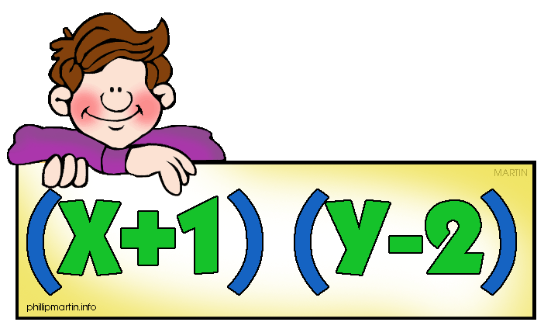
Our math unit right now is very engaging as we are discovering algebra is not so bad. In fact, it is fun! We have used pattern blocks to create various shapes, and then we wrote equations to represent the shapes. The students used hexagons, rhombi, trapezoids, and triangles. After they developed a shape and equation, they were challenged to create an equivalent shape with different pattern blocks to see if the equations would balance. We also worked on coin equations where we took a specific value, such as $.58 and came up with various equations that would equal the given value, such as 2q + n + 3p = $.58.

Social-Emotional
We are very excited to introduce a new way for students in the gifted program to share their work, ideas, and creativity. Each student has received a Weebly website account that will serve as their portfolio for the gifted program. We have been working very hard this month setting up the sites and learning how to use Weebly, along with refreshing our skills with Google mail, the drive, and Classroom. This not only allows students an authentic way to create a portfolio, it also gives them a way to share what they are doing with other gifted students across the district, and with family members. Each website is password protected, so in order to view the site, the students will need to give permission to do so.

As you can see, we are extremely busy in the time we have, but we are all enjoying every moment of it!

Thank you for signing the learning contracts. It's so important that the students know we are all working together with them, and if you have any questions, please feel free to contact me at anytime.

Attached is the permission slip for Camp Duncan, our District 70 Gifted field trip. The kids have a wonderful time each year getting to know everyone and participating in great team building activities. Please return the slip and payment by Friday, October 13 to the GTE classroom.

Kristin Morden
GTE Resource Teacher
kmorden@d70schools.org

