3rd Grade October Gifted News

The Gifted students have continued to work hard this month! Here is an update on what we are currently working on. It was great to see you at conferences and talk about the wonderful progress the students have made!

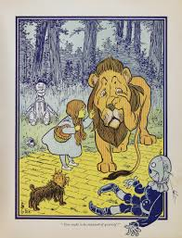
Reading:

We have continued our novel study of Wizard of Oz. As we read, we stop along the way to reflect upon the readings and complete higher-level thinking activities. Students are also learning how to annotate while reading and find text evidence to support questions about the reading. For example,
Fear and courage go together when… An empty cottage can be a refuge when… The students are also doing a great job responding to thoughtful writing prompts in their Wizard of Oz journals.

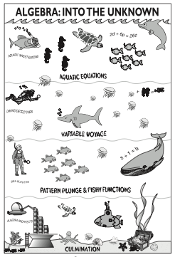
Math: Algebra into the Unknown
The students have continued their unit on "Algebra into the Unknown." We recently progressed into a deeper level, Variable Voyage, where they uncover the wonders of algebraic unknowns! Students are learning about number relationships in an equation and discover that an "unknown" has a consistent value within an equation. It is exciting to see the students apply these algebra concepts in this unit! Take a look in your child’s binder to see all of the algebraic thinking that they have done!

Gifted Team Time
Each week, students in 3rd, 4th, and 5th grade gifted classes all come together for special Gifted Team Time activities. For the last several weeks, our focus has been on having a Growth Mindset. Through Khan Academy’s Learn Storm resources, students are learning about the brain and how to build a strong mindset. Even though these students are very bright, it is still important to grow your brain by having a Growth Mindset!

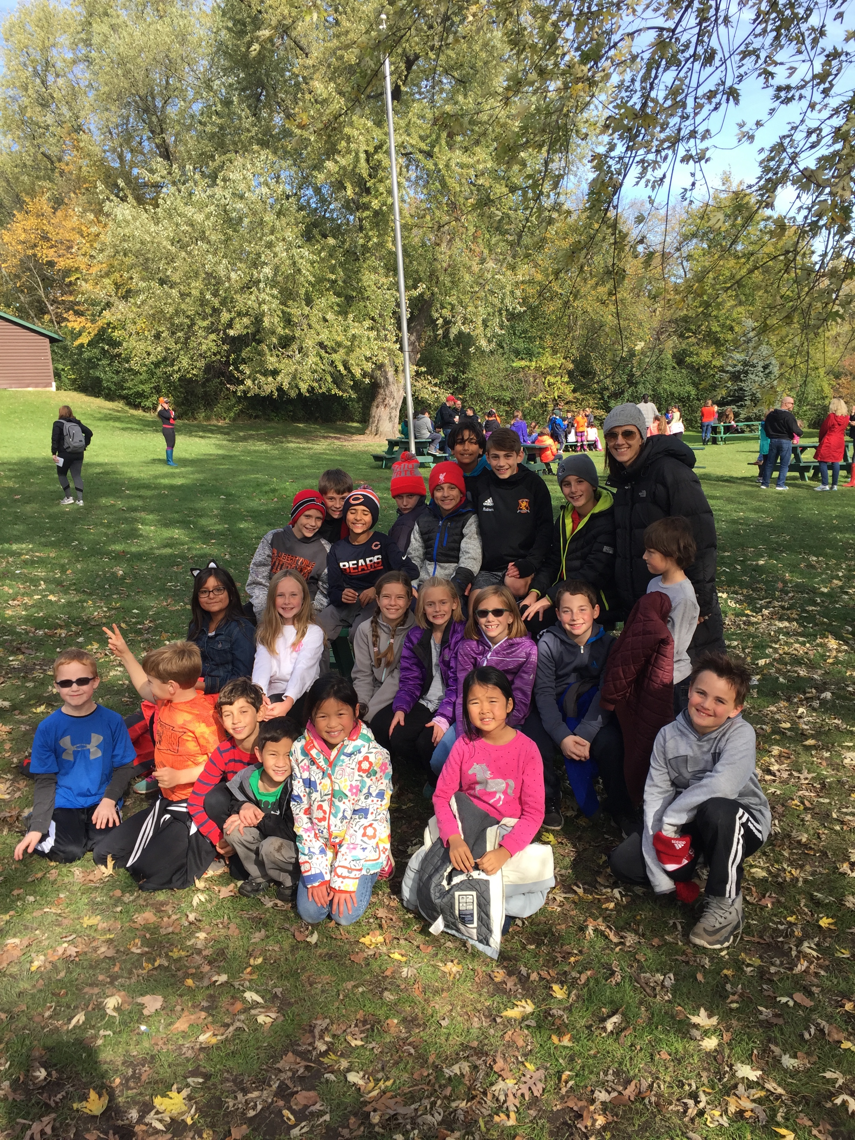
We had an AMAZING time socializing with our gifted friends at Camp Duncan! It was great to see how the students showed a Growth Mindset during our activities. They participated in the Rock Climbing Wall, Team Games in the forest, and Camp Duncan’s version of an Escape Room! If you would like to see some pictures from our day, please visit your child’s Weebly website.

Mrs. Kristin Morden
GTE Resource Teacher

